Activity 5
Ryan Coon
SWE-520
Professor Curtis Thompson
January 28, 2026

Part I
Layered Architecture Design for Asset Management System
User Interface Layer
- Purpose - This layer provides the interface for staff working in the field using mobile devices to interact with the system.
- Components:
  - Mobile app UI for asset data entry and updates (buildings, vehicles, equipment).
  - Responsive web interface for office staff to view and manage assets.
- Key Features - Intuitive forms for asset input, real-time updates, offline data capture with synchronization when online.
User Communications & Authentication and Authorization Layer
- Purpose - Manages communication between user devices and the system backend, ensuring secure access.
- Components:
  - Communication protocols (RESTful APIs, WebSocket for real-time updates).
  - Authentication mechanisms (OAuth, multi-factor authentication).
  - Authorization controls to ensure users can only access and modify permitted asset data.
- Key Features - Secure data transmission, session management, role-based access control.
Information Retrieval and Modification Layer
- Purpose - Handles business logic related to asset data processing, integration, and validation.
- Components:
  - Services to retrieve asset information from integrated existing databases.
  - Logic to merge and synchronize data from multiple sources.
  - Validation rules for new or updated asset information.
- Key Features - Data consistency checks, conflict resolution, integration middleware or API gateways to connect legacy asset databases.
Transaction Management and Database Layer
- Purpose - Manages database transactions ensuring atomicity, consistency, isolation, and durability (ACID properties).
- Components:
  - Centralized database or distributed database system to store consolidated asset information.
  - Transaction management system to handle concurrent updates from multiple users.
  - Data replication and backup mechanisms.
- Key Features - Reliable data storage, concurrency control, recovery from failures.

Layer | Responsibilities
User Interface | Mobile and web interfaces for data entry and viewing
User Communications & Authentication and Authorization | Secure communication, user authentication, and access control
Information Retrieval and Modification | Business logic, data integration, validation, and synchronization with existing databases
Transaction Management and Database | Data storage, transaction handling, concurrency control, and backup

This layered architecture ensures modularity, scalability, security, and ease of integration, meeting the utility company’s requirements for a robust asset management system accessible by field staff on mobile devices.

Part II
Use Case Specification: Report Status
System | Weather Station
Use Case | Report Status
Actors | Weather information system, Weather station
Data | The weather station sends a status report including operational health of sensors, battery level, communication status, and any detected faults or errors.
Stimulus | The weather information system requests a status update from the weather station, either periodically or on demand.
Response | The weather station transmits the current operational status and health information to the weather information system.
Comments | Status reports help monitor the station’s functionality and detect issues early. Frequency of status reporting may vary depending on system needs.

Use Case Specification: Reconfigure
System | Weather Station
Use Case | Reconfigure
Actors | Weather information system, Weather station
Data | Configuration parameters such as data reporting frequency, sensor calibration settings, communication protocols, and thresholds for alerts.
Stimulus | The weather information system sends new configuration settings to the weather station to update its operation.
Response | The weather station applies the new configuration settings and confirms successful reconfiguration back to the weather information system.
Comments | Reconfiguration allows remote adjustment of station behavior to optimize data collection and communication without physical intervention. Frequency of status reporting may vary depending on system needs.

Part III
Class MessagingSystem
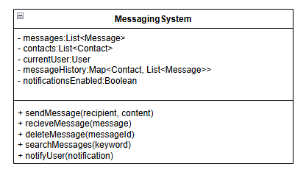
Class: Printer
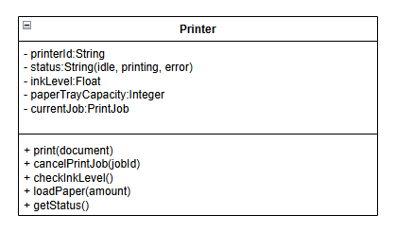

Class: MusicSystem
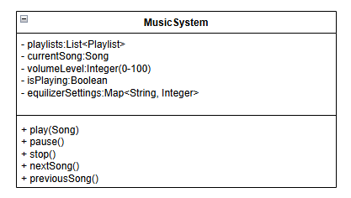
Class: BankAccount
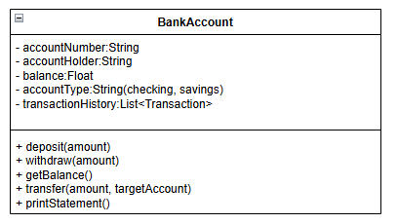

Class: LibraryCatalogue
